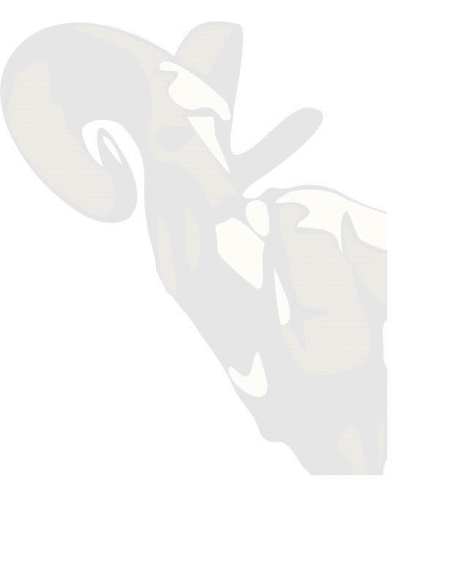
Building on a foundation of more than 85 years of history, the staff at Big Horn Federal still stands tall as we move forward with our continued commitment to our communities. As many of you know, my life has been interwoven with Big Horn Federal even before I was born. In 1972, two years before my existence, my parents were seeking to find a way back to the Big Horn Basin, a place they thought of as home. Thanks to the CEO at that time, William Shelledy Sr. who caught wind that they were trying to return, a job offer was provided and a staff of 7 expanded to 8.

From my earliest memories of being associated with Big Horn to its most current version, I see the presence of the bank in almost every aspect of the communities we serve. This history with the bank starts with my earliest memories, and even some pictures that were used in local advertising at the age of three. As I grew, I starting seeing more impact with sponsorships in all of our communities as I traveled the Big Horn Basin playing a myriad of sports. I even have a 29 year old knee surgery thanks to Big Horn Federal’s involvement in some bed races during our local community fair. Being 18 at the time and during the events of the Days of 49 for which I can still remember Dixie Cummings, a 42 year employee of the bank, putting her life on the line driving that crazy contraption down Main Street. In my youth and now as an adult it is a given that Big Horn Federal and its staff is and will always be fully engrained into the fabric of our communities.

Although I went away for a while, fifteen years to be precise, it was with open eyes that I returned to a place that never wavered on that commitment to community. Everywhere I looked, I could see Big Horn Federal’s involvement in trying to make our communities better. In many cases, I never fully correlated or even contemplated the impacts that this small town bank has produced over the years, but as I reflect, all I can be is so very proud of all of those employees that have made a difference over this bank’s history.

Now as an adult, I realize the vacuum that would be created all too well if that support was not in play. That is why it is so necessary to constantly ask myself how we can continue to make a difference. I am often in awe and sometimes perplexed on how much of a need there is to be a consistent force in our small communities, I appreciate your support as customers of the bank that continue to allow us to make a difference. To my current and historic staff, know that I am so very proud of your personal contributions. Not only are you best bankers around, but I fully recognize that you wear so many different hats. Some of you are coaches, firemen, booster club members, umpires, referees, board members and treasurers and a relied upon volunteer base for all those we serve.

To help memorialize this, a few years ago we started an initiative with a simple foundation of recognizing our contributions with a simple symbol. A red tee shirt to be exact, to be worn (when appropriate) by our staff in those moments of volunteerism. We tagged these shirts with verbiage conveying, “Serving you with Interest”. Not only was this created to pay homage to an old advertising slogan, but the meaning is actually much deeper.

We recognize at Big Horn Federal that our success is quite frankly tied to your success. When you prosper and grow, chances are we are doing the same. Therefore, the pressure to give back is as strong as ever. The volunteer squad is part of that process and the tag line is to remind us that your success is our success. Because our communities have been so successful it has allowed us to enhance our services. More recently, this can be found with upgrades within some of our facilities. New buildings in Powell, Greybull (Ram’s Head Insurance) and the most recent being in Worland, have brought first class facilities to help serve our customers and communities better. Our expanded services are not only in brick and mortar but also be seen in the form of ATMs with locations expanding to Basin and Riverton and Byron, not to mention additional locations that have been put into play in Cody and Powell. While we are at it, we are also proud to announce that we are reestablishing our Insurance presence in Thermopolis once again.

One last story before we wrap up. My youngest son was playing baseball this last year at his final tournament in Powell. I was not able to attend all of the games, but I was able to see the last two. A friend and customer commented to me that “no matter what happens here, Big Horn Federal will make it to the finals”. I was a little taken off guard and must have had a bad poker face in the moment. He laughed and pointed out that Big Horn Federal was sponsoring both the Basin/Greybull team along with the Powell team who were playing against each other. He went on to say that it was a bit over the top as regardless of the winner, the next game could be the same as the winner could play a Lovell team who was being sponsored by……you guessed it Big Horn Federal. Finally catching up to my friend, I remember smiling and saying we have been fortunate and always glad to be in a position to help.

So in closing, a shout out to all of you, who have chosen to bank local and placed us in a positon to make a difference. Knowing the staff at Big Horn Federal, they will continue to stand tall in all our endeavors but your support and kind words of recognition continue to challenge us to be better and we will continue to meet that challenge head on.

Respectfully

John Coyne III
Chairman, CEO, & President
Big Horn Federal

